Module 7.1 - Function Testing
Nathan Spasaro
CSD 325
10/18/2026
The following stages document how changes to city_country() affected the original unit test. Screenshots show the program output and the expected passing or error results.

1. Initial function and output
def city_country(city, country):
return f"{city}, {country}"

The function initially accepts two arguments and returns a formatted city-country string. Three calls were executed in city_functions.py.
Figure 1. Initial execution — three city-country results
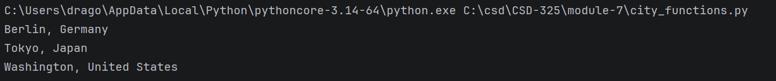

2. Original unit test — passed
import unittest
from city_functions import city_country
class TestCities(unittest.TestCase):
def test_city_country(self):
result = city_country("Santiago", "Chile")
self.assertEqual(result, "Santiago, Chile")

Figure 2. Original unit test — passed
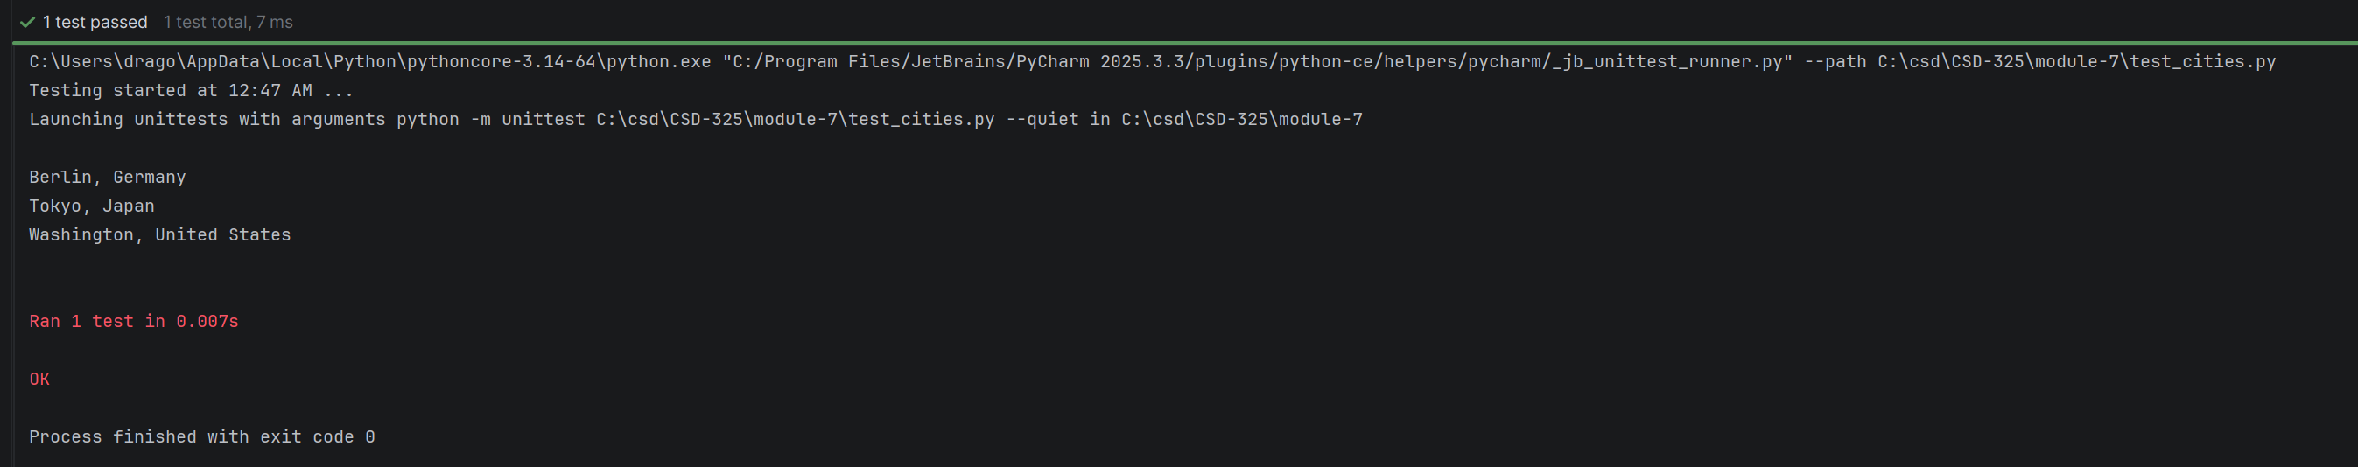

3. Population made required — error
Changed the function signature and return format. The unchanged two-argument test now raises a TypeError because population is required.
def city_country(city, country, population):
return f"{city}, {country} - population {population}"

Figure 3. Unit test — missing population argument
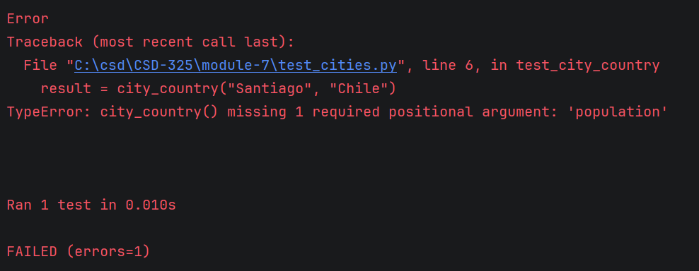

4. Population made optional — passed
Assigned population a default of None and returned the original two-field format when no population was supplied.
def city_country(city, country, population=None):
if population is not None:
return f"{city}, {country} - population {population}"
else:
return f"{city}, {country}"

Figure 4. Original unit test — passed again
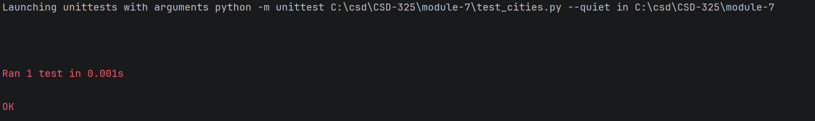

5. Language made required — error
Changed the signature to require both population and language. The unchanged original test raises a TypeError for two missing arguments.
def city_country(city, country, population, language):
return f"{city}, {country} - population {population}, {language}"

Figure 5. Unit test — missing population and language arguments
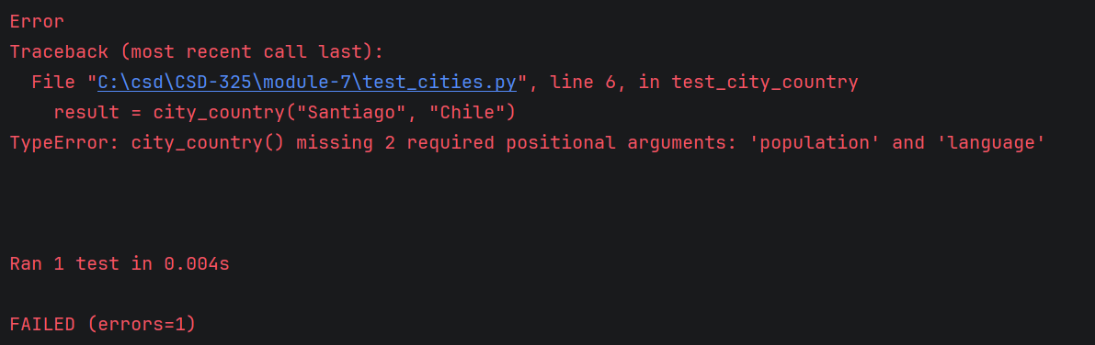

6. Language made optional — passed
Assigned defaults to both optional parameters. Conditional branches now format the output based on the arguments supplied.
def city_country(city, country, population=None, language=None):
if language is not None and population is not None:
return f"{city}, {country} - population {population}, {language}"
elif population is not None:
return f"{city}, {country} - population {population}"
elif language is not None:
return f"{city}, {country} - language {language}"
else:
return f"{city}, {country}"

Figure 6. Original unit test — passed after both parameters became optional
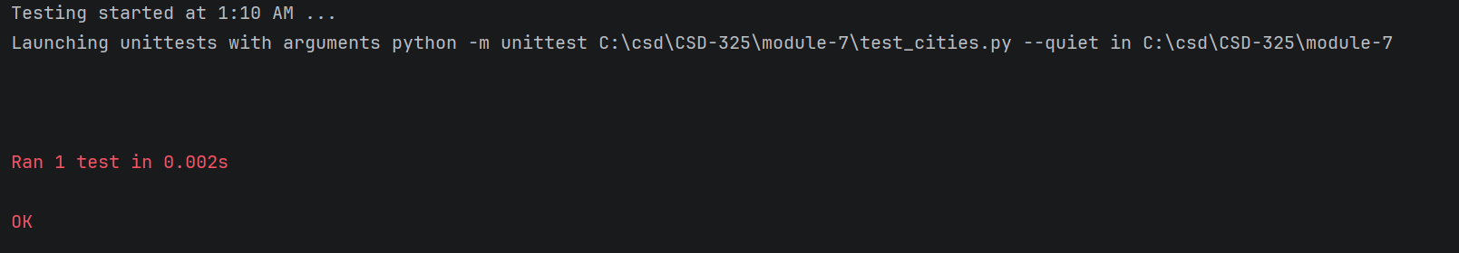

7. Final execution — three argument combinations
The final program demonstrates two, three, and four arguments. The full final function is shown in Section 6; the calls below appear under the main guard in city_functions.py.
if __name__ == "__main__":
print(city_country("Berlin", "Germany"))
print(city_country("Tokyo", "Japan", 14000000))
print(city_country("Washington", "United States", 700000, "English"))

Figure 7. Final execution — all three formats
